**ASSIGNMENT-3**

**1.(a) Create table SUBJECT and insert appropriate values.**

|  |  |  |  |
| --- | --- | --- | --- |
| **Column Name** | **Data Type** | **Size** | **Constraints** |
| SubjectCode | Varchar2 | 6 | Primary key |
| SubjectName | Varchar2 | 30 | Not null |
| DeptCode | Varchar2 | 3 | Foreign key Department(DeptCode) |
| Semester | Varchar2 | 4 | Not Null |

CREATE TABLE Subject2053(SubjectCode VARCHAR2(6) PRIMARY KEY,SubjectName VARCHAR2(30) NOT NULL,DeptCode VARCHAR2(3) REFERENCES Department2053(DeptCode),Semester VARCHAR2(4) NOT NULL);

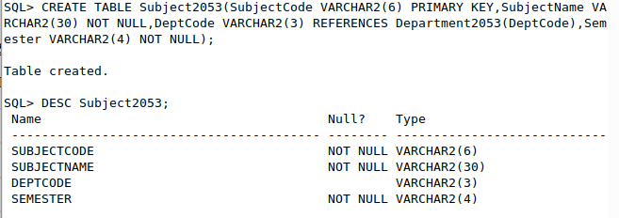

**(b) Insert rows in all the table.**

INSERT INTO Subject2053(SubjectCode, SubjectName, DeptCode, Semester) VALUES ('CS301','Data Structure', 'CSE', 'SEM3');

INSERT INTO Subject2053 (SubjectCode, SubjectName, DeptCode, Semester) VALUES ('CS302','Computer Organization', 'CSE', 'SEM3');

INSERT INTO Subject2053(SubjectCode, SubjectName, DeptCode, Semester) VALUES ('CS501','Discrete Mathematics', 'CSE', 'SEM5');

INSERT INTO Subject2053(SubjectCode, SubjectName, DeptCode, Semester) VALUES ('CS502','Data Communication', 'CSE', 'SEM5');

INSERT INTO Subject2053(SubjectCode, SubjectName, DeptCode, Semester) VALUES ('ECS501','Data Base systems', 'ECE', 'SEM5');

INSERT INTO Subject2053(SubjectCode, SubjectName, DeptCode, Semester) VALUES ('EC501','Analog Signals', 'ECE', 'SEM5');

INSERT INTO Subject2053(SubjectCode, SubjectName, DeptCode, Semester) VALUES ('CS503','Operating Systems', 'CSE', 'SEM5');

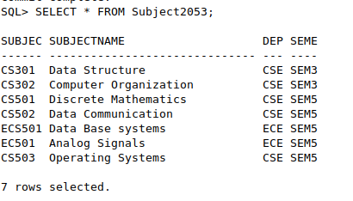

**2.(a) Create table: RESULT**

|  |  |  |  |
| --- | --- | --- | --- |
| **Column Name** | **Data Type** | **Size** | **Constraints** |
| RollNo | Number | 6 | Not Null, Foreign key Student |
| Sub_code | Varchar2 | 8 | Not null |
| Marks | Number | 3 | <=100 |
| Pass Marks | Number | 2 |  |
| Primary key (rollno,Sub_code) | | | |

CREATE TABLE Result2053(RollNo NUMBER(6) NOT NULL,Sub_code VARCHAR2(8) NOT NULL,Marks NUMBER(3) CHECK (Marks<=100),PassMarks NUMBER(2),PRIMARY KeY(RollNo,Sub_code),FOREIGN KEY(RollNo) REFERENCES Student2053(RollNo));

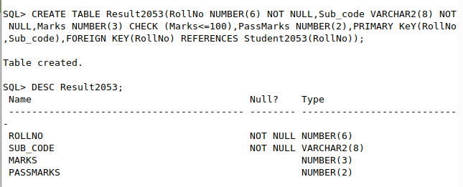**(b) Insert rows in all the table.**

INSERT INTO Result2053(RollNo, Sub_code, Marks, PassMarks) VALUES (1001, 'CS501', 68,40);

INSERT INTO Result2053(RollNo, Sub_code, Marks, PassMarks) VALUES (1002, 'CS501', 76,40);

INSERT INTO Result2053(RollNo, Sub_code, Marks, PassMarks) VALUES (1003, 'CS501', 91,40);

INSERT INTO Result2053(RollNo, Sub_code, Marks, PassMarks) VALUES (1001, 'CS502', 38,40);

INSERT INTO Result2053(RollNo, Sub_code, Marks, PassMarks) VALUES (1002, 'CS502', 81,40);

INSERT INTO Result2053(RollNo, Sub_code, Marks, PassMarks) VALUES (1003, 'CS502', 82,40);

INSERT INTO Result2053(RollNo, Sub_code, Marks, PassMarks) VALUES (1023, 'CS301', 92,40);

INSERT INTO Result2053(RollNo, Sub_code, Marks, PassMarks) VALUES (1029, 'CS301', 83,40);

INSERT INTO Result2053(RollNo, Sub_code, Marks, PassMarks) VALUES (1500, 'CS301', 65,40);

INSERT INTO Result2053(RollNo, Sub_code, Marks, PassMarks) VALUES (1023, 'CS302', 75,40);

INSERT INTO Result2053(RollNo, Sub_code, Marks, PassMarks) VALUES (1029, 'CS302', 71,40);

INSERT INTO Result2053(RollNo, Sub_code, Marks, PassMarks) VALUES (1500, 'CS302', 35,40);

INSERT INTO Result2053(RollNo, Sub_code, Marks, PassMarks) VALUES (2001, 'ECS501', 67,30);

INSERT INTO Result2053(RollNo, Sub_code, Marks, PassMarks) VALUES (2002, 'ECS501', 72,30);

INSERT INTO Result2053(RollNo, Sub_code, Marks, PassMarks) VALUES (2101, 'EC501', 77,40);

